**PROJECT REPORT**

As there are two types of call one is “Normal Call” and another one is “Emergency call”. Our project is based on the emergency mode.

We all know when there is no network connectivity our mobile shows “emergency calls only” on the top of our mobile and sometime it shows the “no service”. What it actually means is that when our mobile shows the emergency call only it means that there is no network of that SIM operator but having some network of another operators. By means of which an emergency calls is established.

1. **Flow of normal call.**

when a person makes a phone call the “mobile station firstly connect to the BTS by means of the “Um air interface”. Then BTS transfer the connection request to the BSC(base station controller) by means of Abis interface. BSC allocates a channel to the call and after allocating the channel transfer the request to the MSC(mobile station controller) by means of the A interface . Every operation like AUC (authentication), EIR( Equipment Identity Register ),HLR(home location register), VLR(visitor location register). After processing on these steps the call finally transfer to the G-MSC (Gateway mobile station controller). Then the G-MSC transfers the call to the PSTN( public switched telephone network) as shown in fig.1. 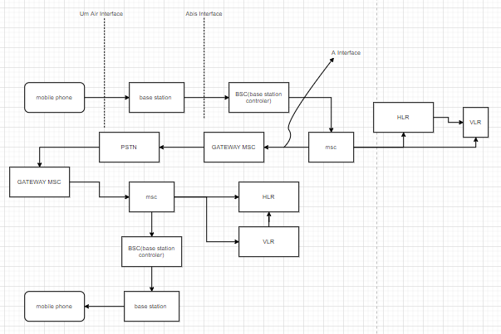 fig. 1 Normal call flow.

1. **Protocols**

There are several protocols working in the flow of a call. But we are working on the MM protocol. Complete study about all the protocols------[2]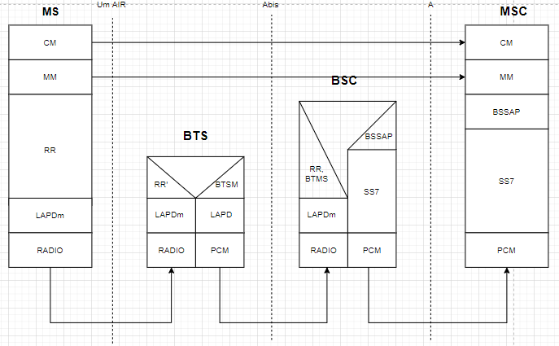

Our project is totally depend upon the MM protocol .

* 1. **DETAILED STUDY ABOUT MM PROTOCOL FOR EMERGENCY CALL SETUP.**

When we make an emergency call a “CM REQUEST” is being send to the network from our mobile station by means of which our network identify what type of call it is. After receiving the CM request it will sends a receiving message back to our mobile station. “CM REQUEST” consist of many parts of messages as shown in the fig.3. --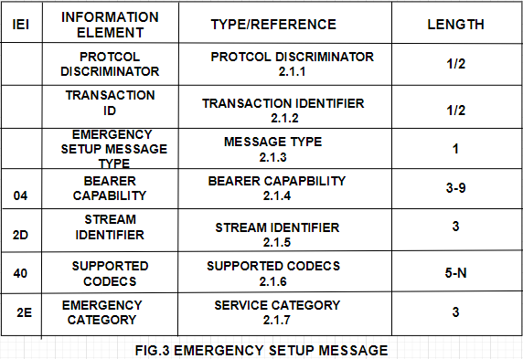-----[3]

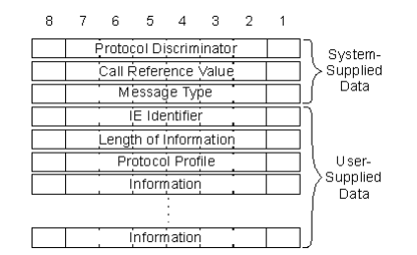

* + 1. **PROTOCOL DESCRIMINATOR**

Prototcol discriminator discriminates between the two protocols by which the network side comes to knows that from which protocol this message was generated for example.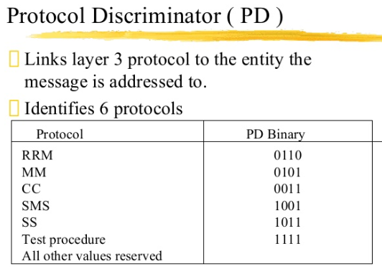

**2.1.1.1: Frame structure for protocol discriminator.**

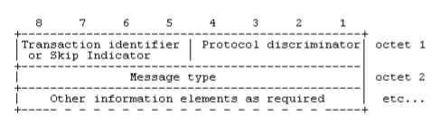

* + 1. **TRANSACTION IDENTIFIER**



In the above frame structure 5-8 bit consist of transaction identifier or skip indicator for every type of MOBILITY MANAGEMENT MESSAGE.When any mobile station wants to send the CM REQUEST, LOCATION UPDAATE REQUEST type of request or at the time of receiving these type of request messge from the network the skip indicator are used these type of bits format..

* Any skip indicator received with any other no rather than 0000bits is being ignored by the network and mobile station because the message with skip indicator other than 0000 is considered as error.
* 5-7 bit is for TI and 8bit of first octet is for TI flag.
* If the message of transaction is initiated from the user side then the flag is ‘0’ and ‘1’for others.
* Hence the TI flag identifies who allocated the TI value for this transaction and the only purpose of the TI flag is to resolve simultaneous attempts to allocate the same TI value.

**2.1.3.1: Frame for transaction identifier**

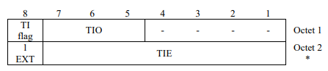

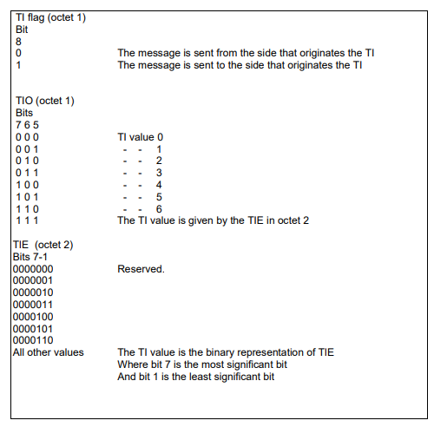

* + 1. **MESSAGE TYPE**

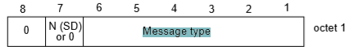

* Here bit 8 bit for the connection to core network earlier than the R99 is assigned as ‘0’ and bit 7 is reserved for the sequence number in messages sent from the mobile station. The messages that are sent by the network side is coded as ‘0’ for both 7 and 8 bits.
* The connection to the core network of R’99 and later, bits 7 and 8 are reserved for sending the sequenced number in messages from the mobile station and the messages sent from the network side the 7 or 8 bit is coded as ‘0’.

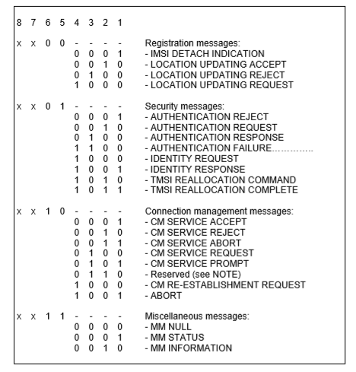

We use the reserved 0110 bit in our project for the modified emergency type call.

.

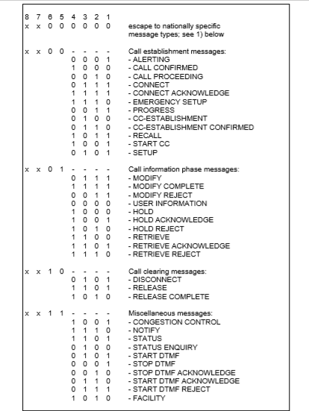

* + 1. **BEARER CAPABILITY**

The purpose of the bearer capability information element is to describe a bearer service. The use of the bearer capability information element in relation to compatibility checking is described in annex B.

The bearer capability has minimum length of 3 octet and maximum length of 16 octet. Bearer capability frame structure is

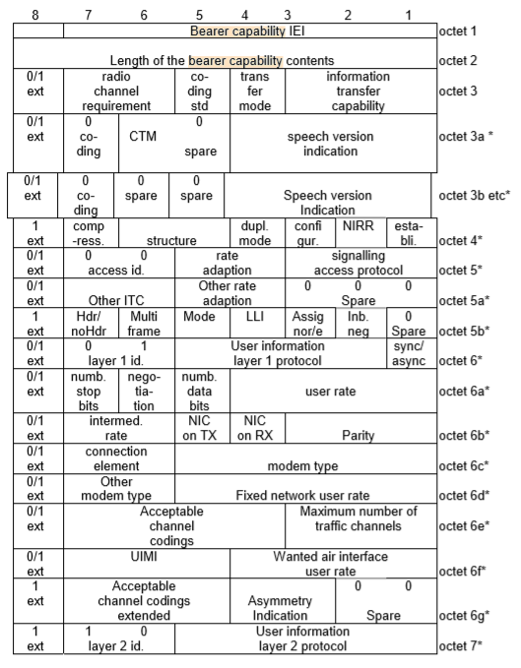

Mobile stations that are not supporting the A/Gb mode and GERAN Iu mode coded ‘0’ for the following:

* Maximum number of traffic channels (octet 6e, bits 1-3)
* Acceptable Channel coding(s) (octet 6e, bits 4, 5 and 7)
  + 1. **STREAM IDENTIFIER**

The purpose of the stream identifier (SI) information element is to associate a particular call with a Radio Access Bearer (RAB), and to identify whether a new traffic channel shall be assigned within the interface controlled by these signalling procedures. The SI value indicated in the CC protocol shall be sent in the RAB setup message. And mobile station is informed the relationship between the call and the RAB.

Frame structure for stream identifier is :

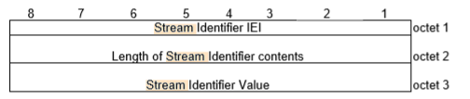

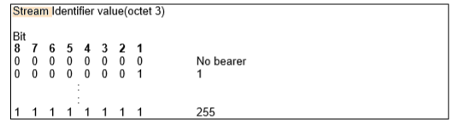

* + 1. **SUPPORTED CODEC LIST**

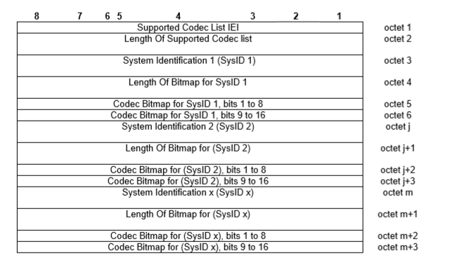 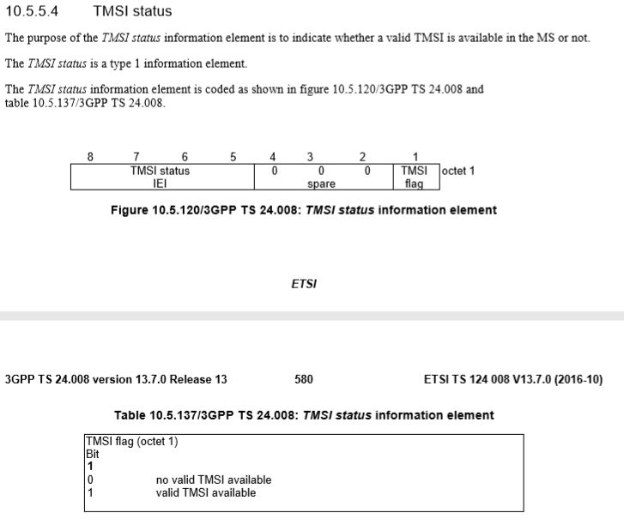

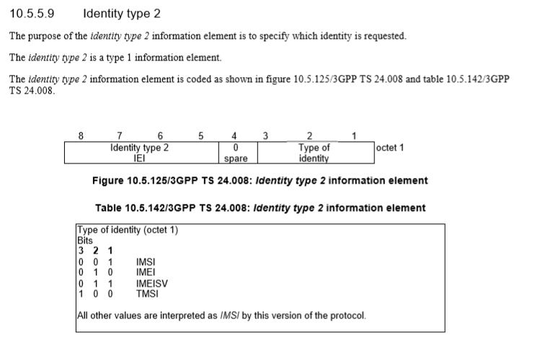

* + 1. **SERVICE CATEGORY**

The purpose of the Service category information element is to provide the network with information about services invoked by the user equipment.

Service category is a type 4 service and having minimum 3 octets.

Frame format for the service category is 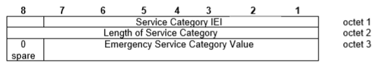

Bit code stack for this is:

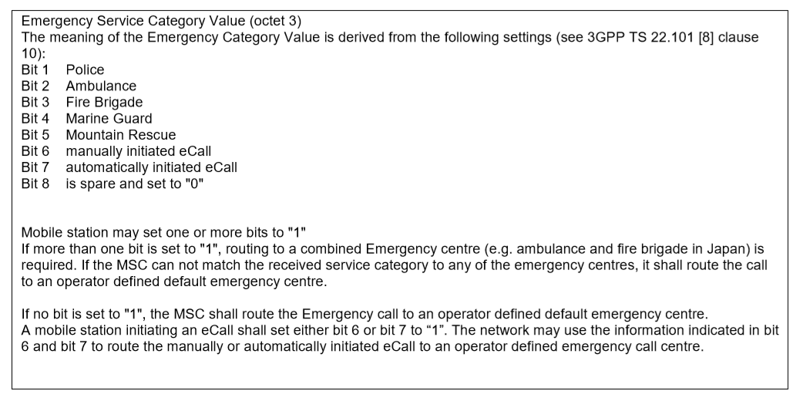

AFTER THE REQUEST IS BEING SERVERD TO MSC

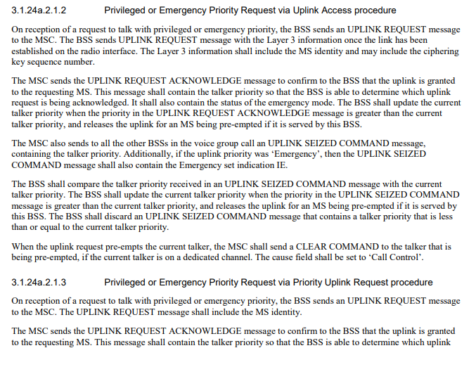 details of connection between the msc and bss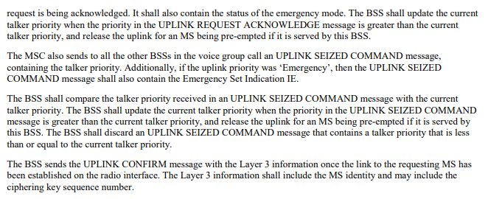FROM <https://www.etsi.org/deliver/etsi_ts/148000_148099/148008/14.01.00_60/ts_148008v140100p.pdf>

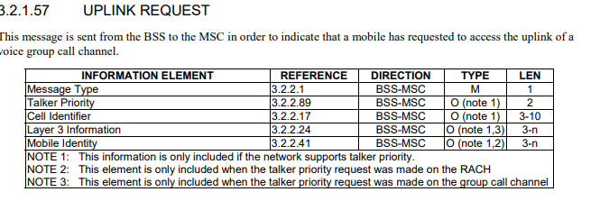

PAGE NO 73.

**ROAMING:**

**AUTHENTICATION:**

**When a mobile is outside the coverage of its HPLMN it initiate the process to connect the roaming network for this it will check the I-WLAN priority list and send theANQP request to the network which was at priority in I-WLAN list.**

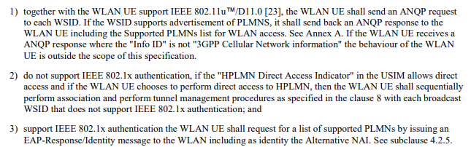**After the BTS of VPLMN provides the channel to the user the user phone sends its IMSI by which the VPLMN divides its further in MCC,MNC and MSIN.**

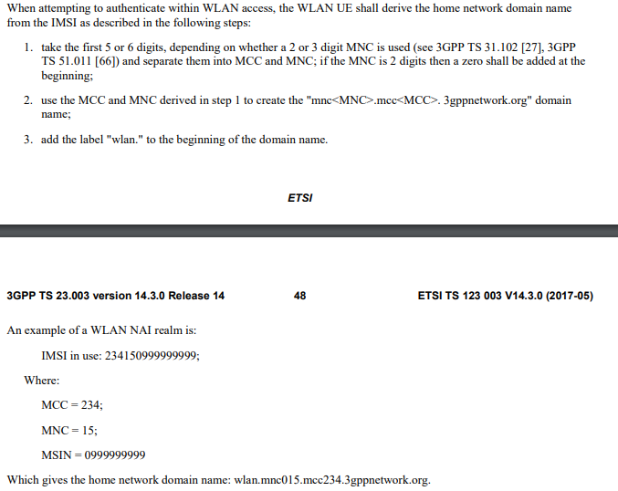

**By the help of this the VPLMN make a domain name as mentioned in the below file** 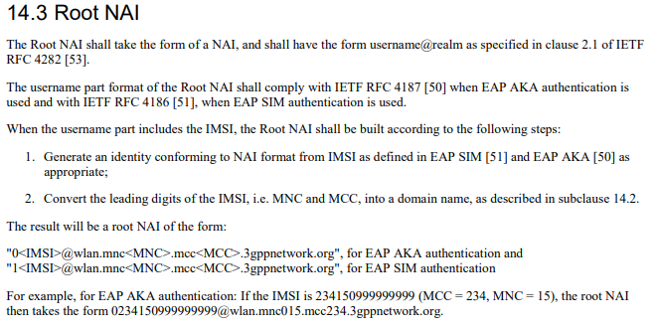

**Then the VPLMN send this domain name to the local AAA server by the help of EAP protocol**

**EAP protocol frame structure**

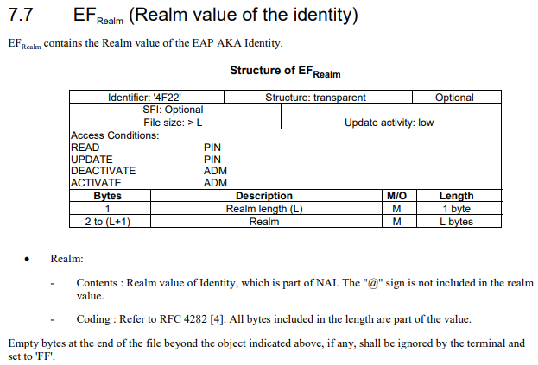

**Completestep by step procedure and exchange of file of EAP are described in** ETSI TS 133 234 V10.1.0 (2011-10) at page(24-25), ETSI TS 129 273 V10.3.0 (2011-06).

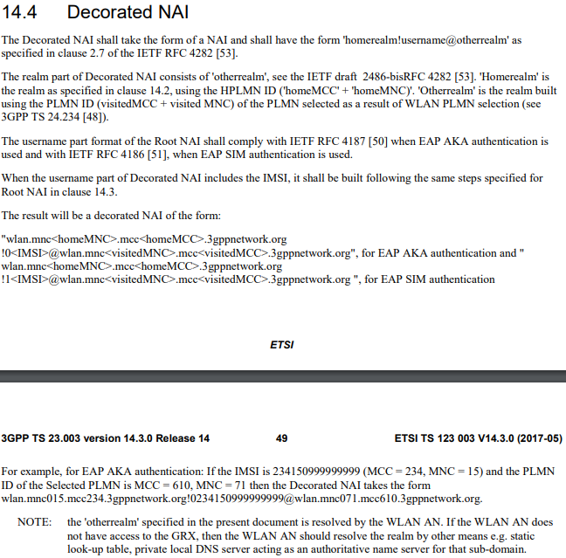**after this by the help of EAP protocol the VPLMN sends this domain name to the AAA server**

**BILLING:**

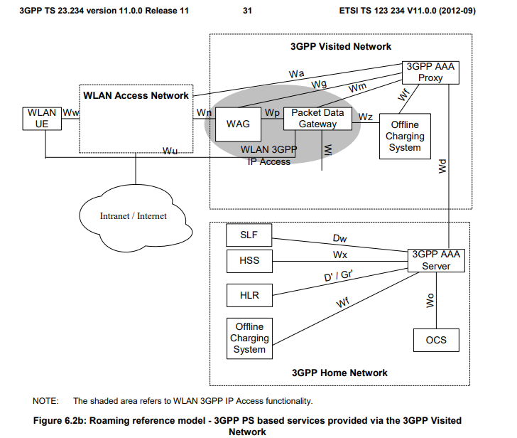

**The HPLMN and the VPLMN is connected through the Wd interface through which the exchange of CDRs take place**

**The complete frame format for the CDR in ETSI TS 132 297 V15.4.0**

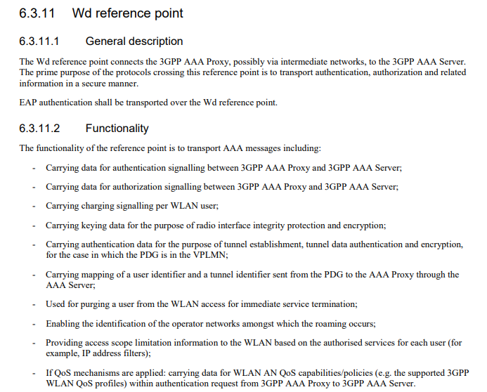

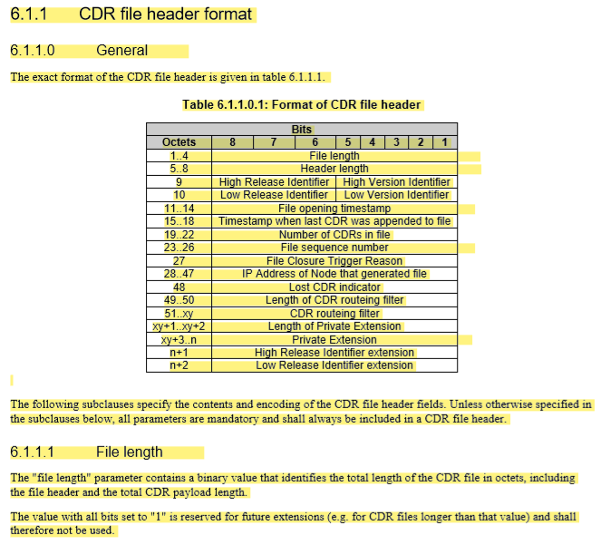

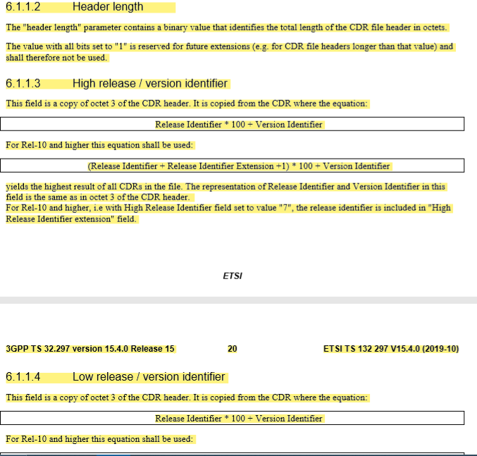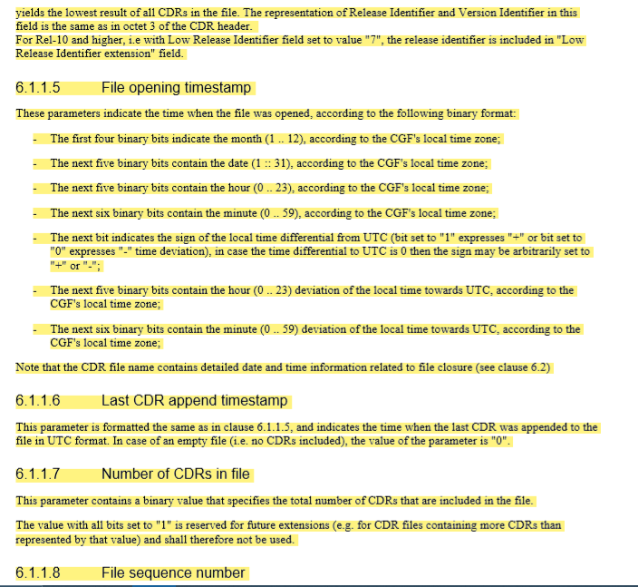**and continued to the next pages on ETSI TS 132 297 V15.4.0**

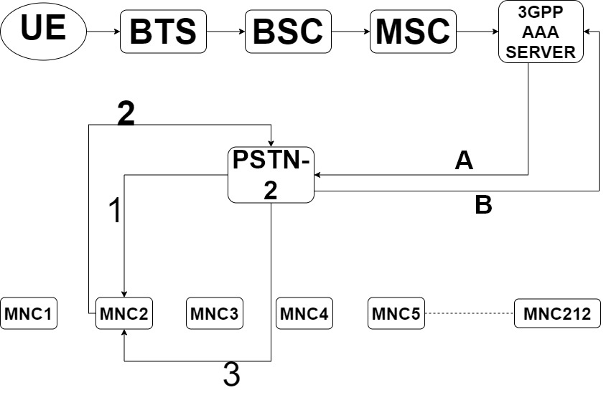

**EXPLANATION OF NEW PSTN**

In the above figure as we can see that the process of the new derived PSTN is same upto the 3GPP server point as 3GPP AAA server. At this point we receive the domain name from the MSC. By the help of this domain name we can easily get the MCC (Mobile country code) and MNC (Mobile network code) as well as the IMSI of the UE. So as mentioned in above fig. the A line shows that a request is being sent to the PSTN 2 with the two values i.e. MNC and MCC which will help our PSTN to find out that from which network the UE actually belongs. Then our PSTN sends a simple request containing UE IMSI and also the service type that the user wants to use to the UE home network for checking whether the customer is valid and is he able to use that service or not as shown by 1 in the above fig. Then the home network will confirm by the help of the received IMSI from new PSTN whether the service is being provided to that customer or not, if the customer is able to avail that service it will respond yes and if not then no. But here no data will be forwarded to the PSTN about the customer as shown by the 2 in the above fig. Now after receiving that particular request response by PSTN it will again forward it to the AAA server as shown by B after this the AAA server again sends a message to the PSTN which contains the connecting time of that call and the PSTN generates the billing process and at the same time it will send the call connecting time to the home network which is shown by the 3. After this when the call ends the AAA server releases one more message towards the PSTN which is the call ending time after that the PSTN will generate a CDR( call detail record) file and send the call ending time to the home network. Through this process no data about the caller will be exchanged except the IMSI. Also there is no physical connection between the Home network and the visitor network will be established during the whole call hence it is safe.

**Sample solved frame structure**

1. Solved frame structure for protocol discriminator

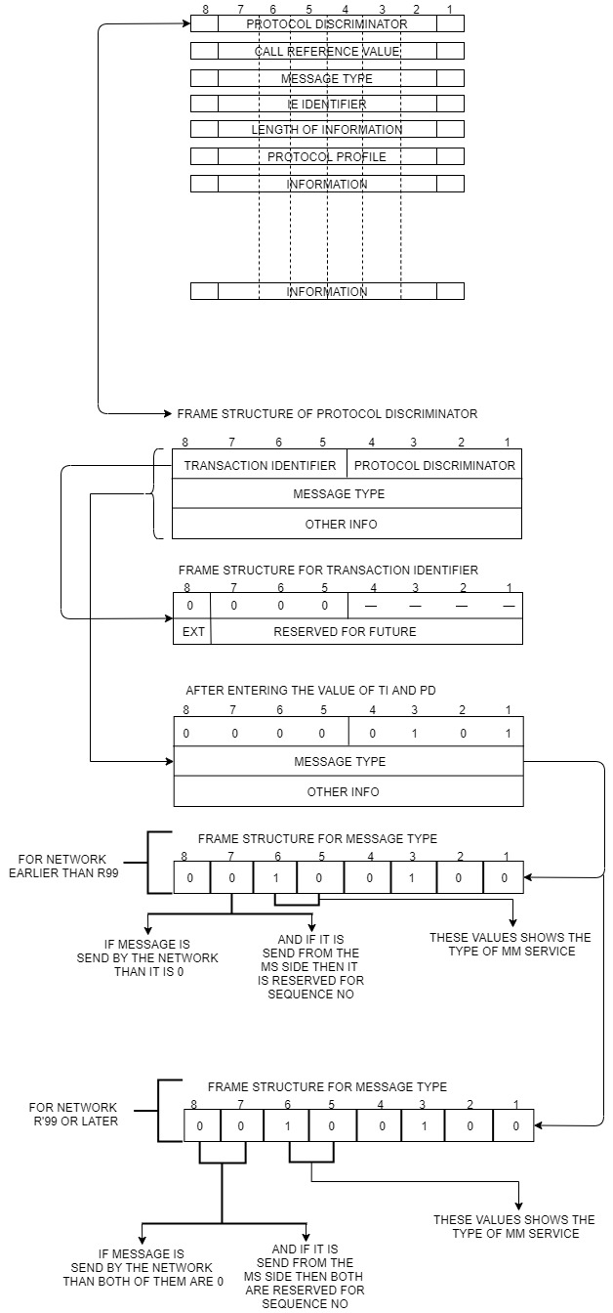

1. **Solved frame structure for message**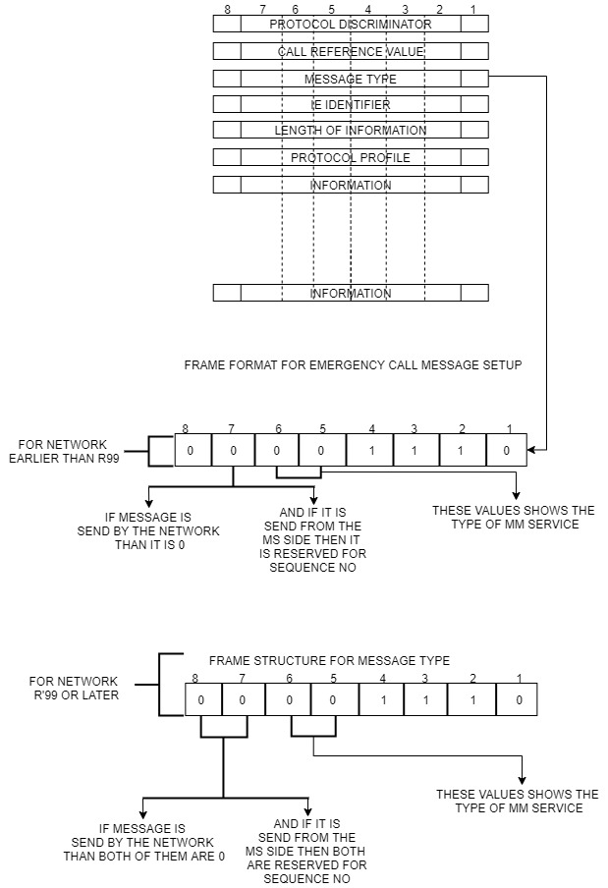

2.1 Modified message type frame format

**REFERENCES**

[1]<https://www.arib.or.jp/english/html/overview/doc/STD-T63v9_60/5_Appendix/R99/24/24008-3k0.pdf>.

[2] <https://www.tutorialspoint.com/gsm/gsm_protocol_stack.htm>

[3] <https://www.arib.or.jp/english/html/overview/doc/STD-T63v9_60/5_Appendix/R99/24/24008-3k0.pdf>

[4] 3GPP TS 24.007: "Digital cellular telecommunications system (Phase 2+); Mobile radio interface signalling layer 3 General aspects".

